Week 14 starting 03 april 06

SM18 Operation Meeting (Tuesdays) 04 april 06
Bench status on Monday 04-04-2006 at: 4/3/2006 10:37:22 AM

11 | A1 | MBAR2251 | PT 12 Warm Up | 295.8
3 | A2 | MBBR2285 | PT 13.1 IAP @ Warm | 298.58
10 | B1 | SSS506 | PT 13.1 IAP @ Warm | 299.11
6 | B2 | SSS335 | PT 6.1 Training 1 | 2.01 HV
7 | C1 | SSS324 | PT 5.2 1.5 KA Quench HF | 1.90
1 | C2 | SSS235 | PT 12 Warm Up | 223.16
9 | D1 | SSS620 | ICS 5 Traveller Last | 298.31
12 | D2 | SSS644 | Prep 5 Cool Down | 105.46
4 | E1 | MBAR2312 | PT 8 Fast De-excitation | 1.90
5 | E2 | MBAR1335 | ICS 4 Final connection | 299.11
2 | F1 | MBAR2311 | PT 12 Warm Up | 20.43
8 | F2 | MBBR2265 | ICS 4 Final connection | 297.32
Tempr. from TBSM18 site

Supervisor: Pierre P. Eq support : 16-3602 :
16 Magnet Tests completed : 7 Dipoles [1097 (3rd time), 1162 REPEATs]
: 6 Arc-SSS (191 REPEAT)
: 3 IR-SSS (652, 655,657)
2251 A1 & correctors : long bench time hence A2 also suffers
D1:620 was on bench & remained connected since Friday 31st till Monday3rd
General Points :
- Situation from Cryogenics: J-P Lamboy or ACR Rep.
- Situation from (SSS, SSSS) : J.Halik
- Situation SSSS ; OP issues : Eric, GHH
  - IR-SSS list, Magnetic Measurment, S4 transport and connection problems.
- Situation for long week-end April/May

Statistics March 06
- A.O.B.

Tests
Magnets under Test from 26-03-2006 to 01-04-2006
- | Bench | Magnet | Shafts | + | Start Date | Connect  Time | Cooling  Time | Cold Test  Time | Warming  Time | Disconnect  Time | End Date | Total | Signed for
1 | TBA2 | MBAR1334 |  |  | 23-03-2006 | 31 h. | 53 h. | 26 h. | 29 h. | 16 h. | 30-03-2006 | 155 h. | Stand By
2 | TBB1 | SSS657 |  |  | 22-03-2006 | 22 h. | 23 h. | 55 h. | 18 h. | 24 h. | 28-03-2006 | 142 h. | Stand By
3 | TBB2 | SSS191 |  |  | 26-03-2006 | 0 h. | 15 h. | 18 h. | 7 h. | 17 h. | 28-03-2006 | 57 h. | Stripping
4 | TBB2 | SSS327 |  |  | 28-03-2006 | 30 h. | 22 h. | 23 h. | 9 h. | 12 h. | 01-04-2006 | 96 h. | Stripping
5 | TBC1 | SSS222 |  |  | 28-03-2006 | 23 h. | 36 h. | 23 h. | 7 h. | 11 h. | 01-04-2006 | 100 h. | Stripping
6 | TBC1 | SSS239 |  |  | 23-03-2006 | 25 h. | 14 h. | 39 h. | 11 h. | 10 h. | 28-03-2006 | 99 h. | Stripping
7 | TBC2 | SSS192 |  |  | 22-03-2006 | 30 h. | 17 h. | 38 h. | 8 h. | 7 h. | 27-03-2006 | 100 h. | Stripping
8 | TBC2 | SSS328 |  |  | 27-03-2006 | 28 h. | 13 h. | 15 h. | 8 h. | 9 h. | 30-03-2006 | 73 h. | Stripping
9 | TBD2 | SSS652 |  |  | 21-03-2006 | 39 h. | 18 h. | 31 h. | 10 h. | 46 h. | 27-03-2006 | 144 h. | Stand By
10 | TBD2 | SSS655 |  |  | 28-03-2006 | 29 h. | 17 h. | 15 h. | 14 h. | 8 h. | 01-04-2006 | 83 h. | Stand By
11 | TBE1 | MBAR1333 |  |  | 23-03-2006 | 30 h. | 21 h. | 19 h. | 14 h. | 8 h. | 27-03-2006 | 92 h. | Stripping
12 | TBE1 | MBBR2240 |  |  | 27-03-2006 | 27 h. | 22 h. | 24 h. | 17 h. | 9 h. | 31-03-2006 | 99 h. | Stripping
13 | TBE2 | MBAR2237 |  |  | 25-03-2006 | 28 h. | 22 h. | 21 h. | 16 h. | 14 h. | 29-03-2006 | 101 h. | Stripping
14 | TBF1 | MBBL1097 |  |  | 26-03-2006 | 21 h. | 23 h. | 20 h. | 14 h. | 22 h. | 30-03-2006 | 100 h. | Stripping
15 | TBF2 | MBAL1162 |  |  | 24-03-2006 | 27 h. | 23 h. | 20 h. | 17 h. | 10 h. | 28-03-2006 | 97 h. | Stripping
16 | TBF2 | MBAR1269 |  |  | 28-03-2006 | 31 h. | 20 h. | 14 h. | 15 h. | 8 h. | 01-04-2006 | 88 h. | Stripping

Quench Information

- | Magnet | Q1 | Q2 | Q3 | Q4 | Q5 | Q6 | Q7 | Q8 | Q9 | Q10 | Q11 | Q12 | Q13
1 | MBAR1334 | 11538.9 A.  (D1_U) | 12233.8 A.  (D1_L) | 12660.8 A.  (D2_L) |  | - | - | - | - | - | - | - | - | -
2 | SSS657 | 5485.4 A.  (E_MQML12) | 5730.2 A.  (Int_34) | 5822 A. | - | - | - | - | - | - | - | - | - | -
3 | SSS191 | 11620 A.  (QI-34) | 12105 A.  (QE-34) | 12307.6 A.  (QI_34) |  | - | - | - | - | - | - | - | - | -
4 | SSS327 | 10467.2 A.  (QE-34) | 12116.7 A.  (QI-12) | 12440.5 A.  (QI-12) |  | - | - | - | - | - | - | - | - | -
5 | SSS222 | 11522 A.  (QE-34) | 12175 A.  (QI-34) | 12840.7 A.  (QI=12) |  | - | - | - | - | - | - | - | - | -
6 | SSS239 | 11752.5 A.  (QE-12) | 12036.8 A.  (QE_34) | 12268.7 A.  (QE-34) |  | - | - | - | - | - | - | - | - | -
7 | SSS192 | 11211 A.  (QI_12) | 11423.5 A.  (QI_12) | 12025.5 A.  (QI_12) | 12187.5 A.  (QI_12) | 12543.6 A.  (Qe12) | 12850 A. | - | - | - | - | - | - | -
8 | SSS328 | 11340 A.  (No Data) | 12271 A.  (No Data) | 12665.9 A.  (QE_34) |  | - | - | - | - | - | - | - | - | -
9 | SSS652 | 5646.3 A.  (Int_MQML) | 5820 A. | - | - | - | - | - | - | - | - | - | - | -
10 | SSS655 | 5820 A. | - | - | - | - | - | - | - | - | - | - | - | -
11 | MBAR1333 | 11757.7 A.  (D1_L) | 12212.3 A.  (D1_L) | 12474.5 A.  (D2_L) |  | - | - | - | - | - | - | - | - | -
12 | MBBR2240 | 10896.2 A.  (D1_U) | 11873 A.  (D1_U) | 12436.8 A.  (D1_L) | 12849 A.  (D1_U) |  | - | - | - | - | - | - | - | -
13 | MBAR2237 | 11249.6 A.  (D2-U) | 12185.7 A.  (D2-U) | 11999.8 A.  (D2_L) | 12836.7 A.  (D2_U) |  | - | - | - | - | - | - | - | -
14 | MBBL1097 | 11907.2 A.  (D2_U_S13) | 12276.8 A.  (D1_U_S13) | 12712.6 A.  (D2_U_S02) |  | - | - | - | - | - | - | - | - | -
15 | MBAL1162 | 11527.1 A.  (D1-U) | 12373.8 A.  (D1_U) | 12847.6 A.  (D2-U) |  | - | - | - | - | - | - | - | - | -
16 | MBAR1269 | 11754.5 A.  (D2_L) | 12562 A.  (D1_U) | 12703 A.  (D2_u) |  | - | - | - | - | - | - | - | - | -
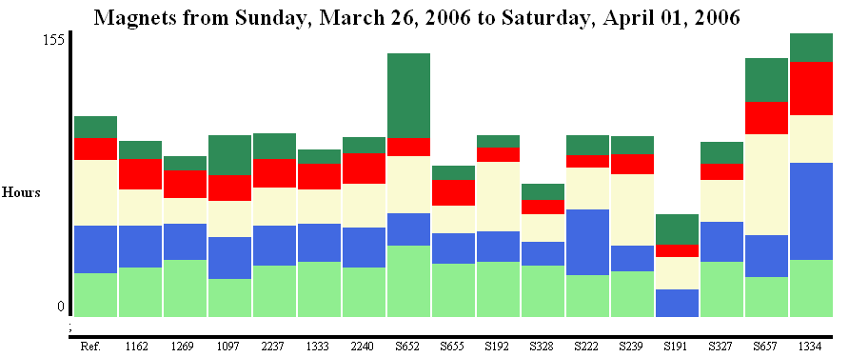
1334 on A2 in cohabitation with 2251 on A1 .. so long cooling time. 652 connect/disconnect issues; 657 cohabitation with arc-SSS on B2 ?

